Exercise 5 : Git-HOL
1) Verifying the Master Branch is in a Clean State
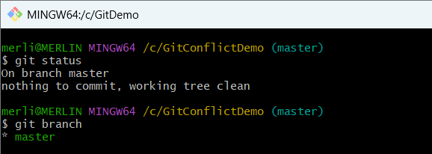

2)Listing Available Local Branches
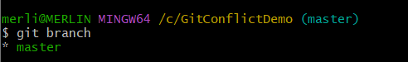

3)Verifying the Remote Repository Configuration
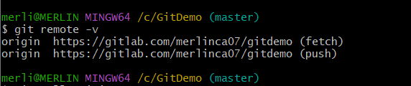

4)Pulling the Latest Changes from the Remote Repository
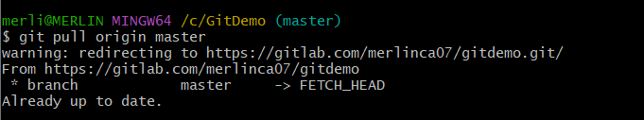

5) Pushing Local Changes to the Remote Repository
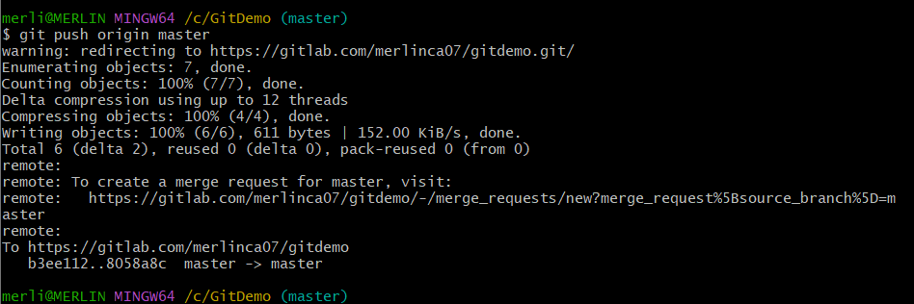

6) Verifying Changes in the Remote GitLab Repository
